Wootton Neighbourhood Plan Survey: overview of results
- How representative are the respondents?
There were 602 residents in the two Census output areas which approximate to Wootton Parish in 2021. That’s equivalent to a 28% response rate, assuming no significant increase/decrease in number residents by 2025. But 103 of these were 15 or under, according to the Census. Since the survey omitted this age group, the response rate is actually equivalent to 40% - which is pretty good.
Were most parts of the village represented? The survey captured postcode data. Postcodes generally include between 15-100 households, but we can map the data to give a broad indication of geographical distribution. (Markers show the post code area centroid, rather than any specific property.) All parts of the parish were represented. (Including Hordley, which is off the map below.)
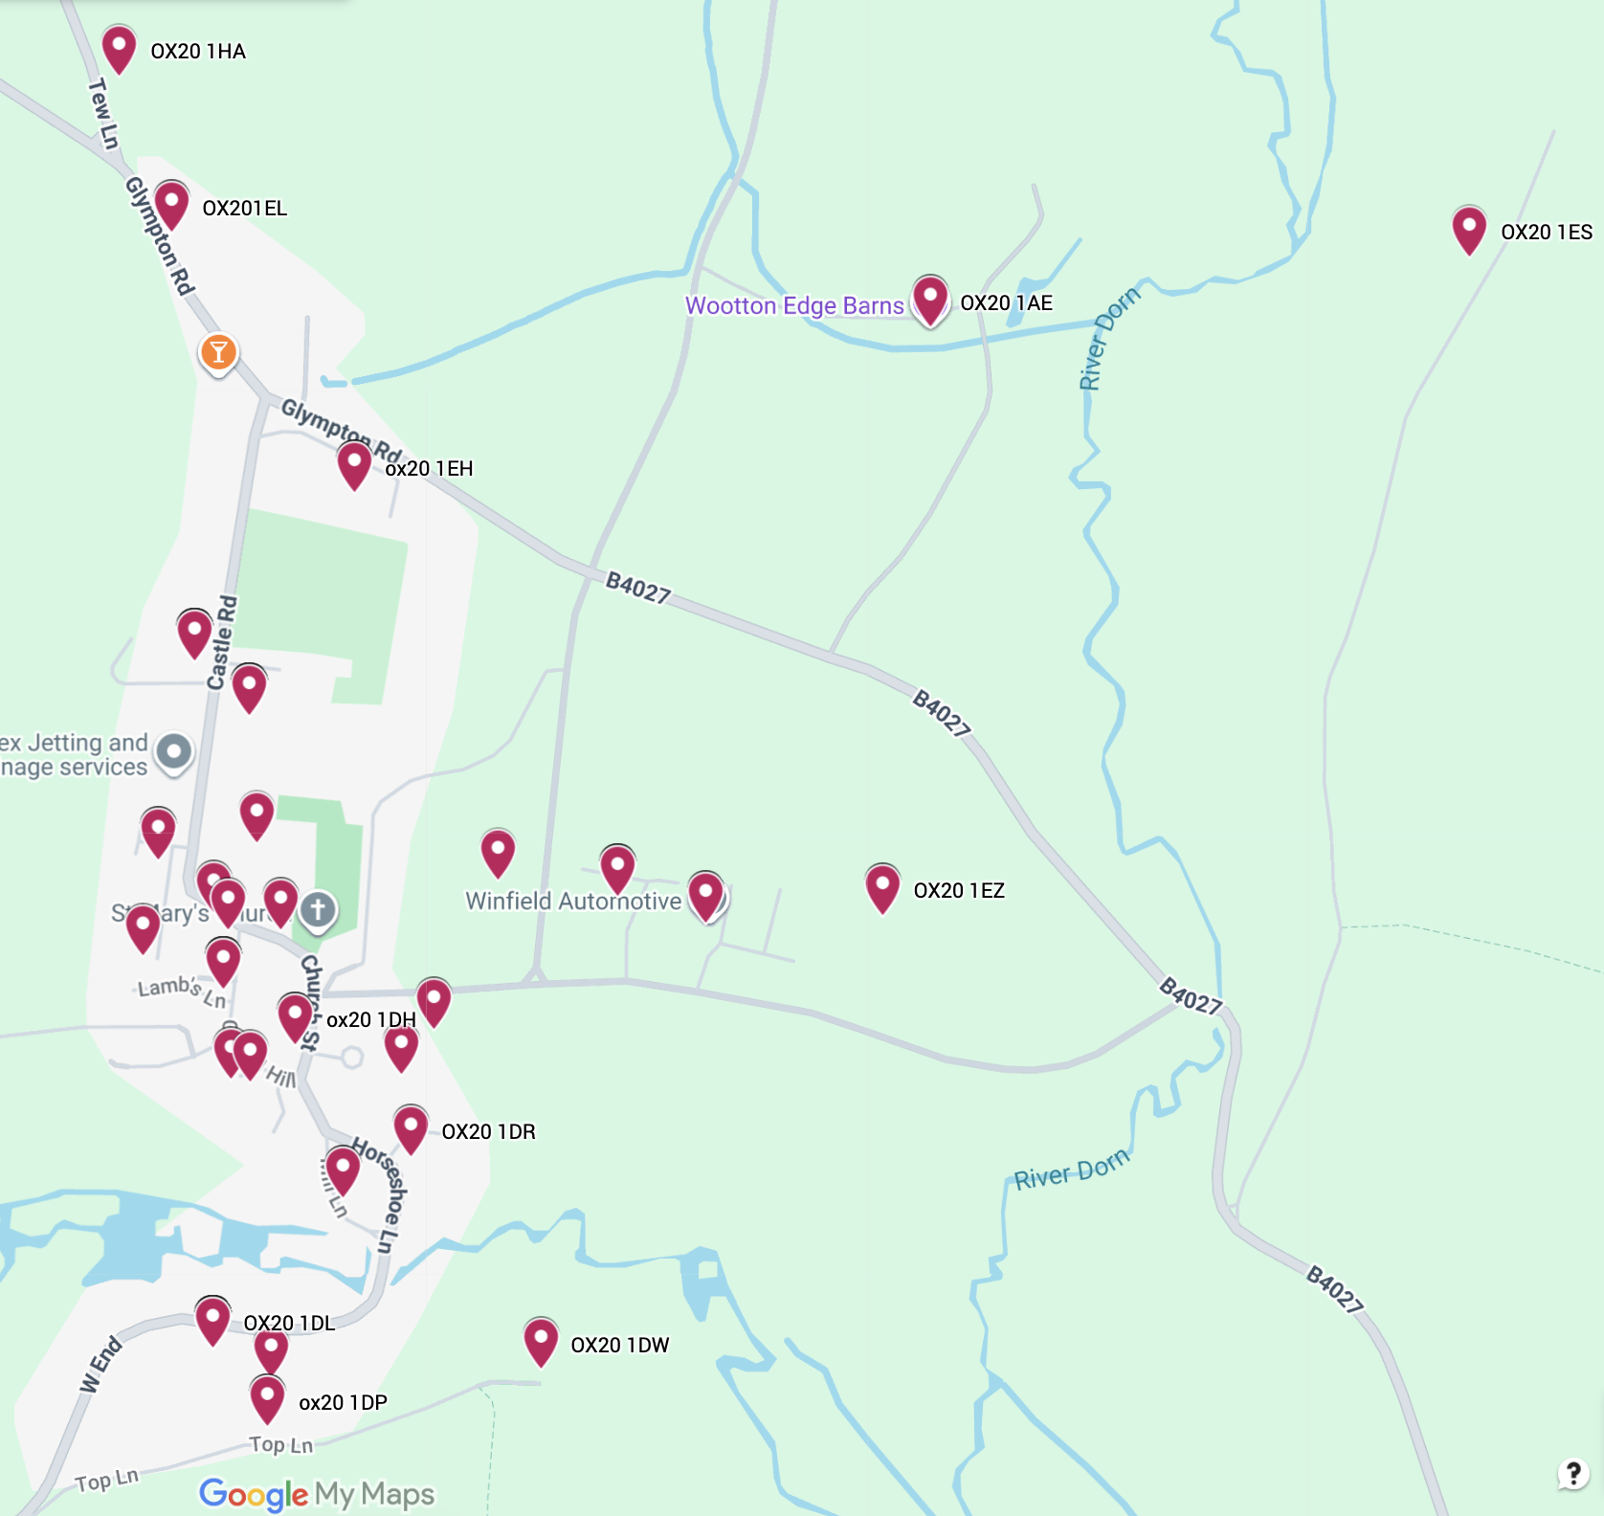
It is also interesting to explore how representative the respondents are compared to, for example, what we know about the 2021 age distribution in Wootton from the Census. The figure on the left, below, shows Wootton’s demographic makeup in 2021 using age groups as close as possible to the survey. The figure on the right shows the Survey distribution. Even accounting for the five-year difference in data, the survey would appear to over-represent older age groups.

- Main findings (selected themes only)

- Demographics of survey respondents

- Majority aged 46–80, with few under 45.
- Most are owner-occupiers, living in Wootton for over 10 years, showing a stable, long-term population.
- Limited representation from renters and younger households.

- Attitudes towards housing development

- Clear resistance to large new estates; preference for incremental infill and conversion of existing buildings.
- Affordable housing is supported when prioritised for local or downsizing residents.
- Concerns noted about traffic, parking, and strain on infrastructure.
- All age groups favour small groups (3–5 houses) or individual builds.
- Support for larger schemes decreases sharply with age.
  - The 46–67 group shows the most consistent preference for small developments and conversions.
  - The 21–45 group expresses slightly more openness to affordable housing and new builds, reflecting younger households’ need for entry options.
- Older respondents show stronger opposition to any modern-style or dense housing.
- Younger respondents are more accepting of modest infill and affordable housing, but still within design limits.
- Owner-occupiers (c. 85%) show strong resistance to large developments and preference for conversions or 3–5-house clusters.
- Renters and housing-association tenants (but a small minority) show higher support for affordable and shared-ownership housing.

- Views on Wootton’s environment and character

- High value placed on green spaces, wildlife habitats, and rural landscape.
- Frequent calls to protect footpaths, trees, and views.
- Environmental sustainability (energy efficiency, renewable energy, biodiversity) viewed positively if sympathetic to village scale.
- All ages value green space, but the 67+ group expresses the strongest concern for wildlife, tranquillity, and landscape protection.
- The 21–45 group more frequently supports renewable energy and sustainability measures, provided they fit the village setting.
- Families with school-age children prioritise transport, schooling, and recreation spaces.
- Retired households emphasise quietness, conservation, and continuity.
- Single adults mention affordability and community inclusion.

- Views on amenities and services

- Requests for better bus links, shop, and pub/café revival.
- Support for maintaining or improving community facilities (hall, playground, church spaces).
- Younger and middle-aged respondents (21–45, 46–67) mention the need for a shop, café, and social hub more often.
- Older groups (67+) focus on maintaining church, hall, and existing amenities, showing continuity preference rather than expansion.

- Transport and mobility

- Younger groups seek better bus services to Oxford and Woodstock for commuting and schooling.
- Older respondents stress footpath maintenance and local accessibility, less concerned with daily travel links.
- Respondents on Castle Road and Glympton Road report traffic and parking issues most often.
- Those in northern postcodes (near Glympton Road) mention road safety and pedestrian access.

- Communication and engagement

- Desire for transparency and regular updates from the parish council.
- Preference for traditional print channels and digital complement, not replacement.
- 46–80 group: overwhelmingly prefers hard copy via Outreach (45–29 responses).
- 21–45 group: more balanced between online and print, with 7 each.
- 80+ group: relies almost entirely on Outreach, with negligible digital uptake.
- Younger respondents (under 45) are the most likely to request multiple channels or other forms (e.g. email, WhatsApp).
- Long-term residents and retirees → “Outreach” and noticeboards.
- Recent arrivals → more use of website, WhatsApp, and digital formats.

- Future vision

- Community vision: Open responses (Q58) repeatedly mention Wootton as friendly, safe, and a haven for wildlife.
- Those favouring no or minimal development emphasise “haven of wildlife” and “safe and quiet.”
- Those open to limited new housing add “affordable” and “sustainable” to their vision descriptors.

- ChatGPT 150-word summary of findings
The Wootton Parish Survey shows strong consensus for limited, locally beneficial development and high value placed on rural character. Most respondents are long-term owner-occupiers aged 46–80, favouring small-scale housing such as individual or 3–5 home developments, and opposing large estates. Affordable housing gains cautious support when reserved for local residents. Older participants prioritise conservation, tranquillity, and traditional communication through Outreach, while younger and newer residents are more open to affordable housing, sustainability measures, and digital engagement. Families highlight transport and local facilities, whereas retired residents focus on preserving village identity. Correlation analysis confirms that age, tenure, and years in residence are strongly linked, forming a stable preservationist core that shapes overall sentiment. Despite demographic differences, the community agrees that Wootton should remain friendly, safe, and environmentally rich, with modest, well-designed growth supporting future generations without eroding its distinctive rural character.

JR: 251031 Wootton Neighbourhood Plan Parish Survey.docx
31st October 2025

